Chapter -2

Literature Survey

In [1] the authors present the strategy and execution of IOT based Home Automation, a steadfast WSN technology will be interconnected through MQTT (Telemetry Transport) protocol which is a publish and subscribe tool to establish the communication among diverse devices via ngrok which is a third-party cloud access provider where our author completely trusts their services. Which might lead to a **point of failure** and does not unravel the **speed of light** problem.

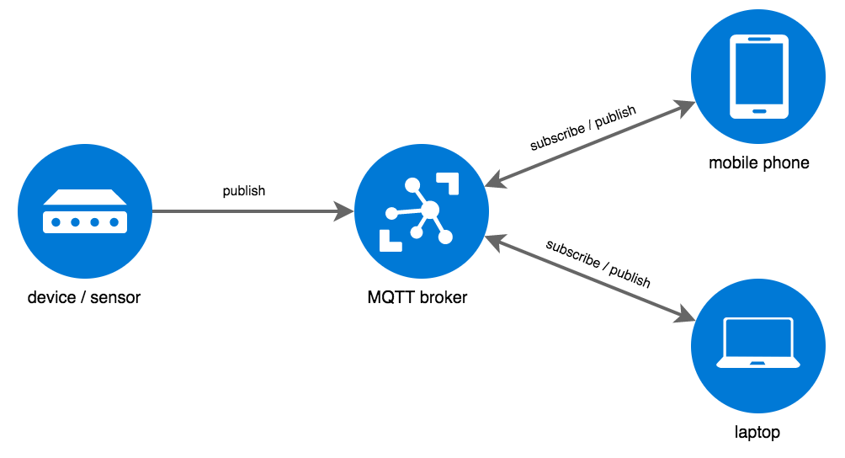

The Inter Planetary File System, “IPFS,” [2] is a cutting-edge peer-to-peer distributed ﬁle system that seeks to connect all computing devices with the similar system of ﬁles i.e. By trading objects with each other. Unlike all other Telemetry Transport protocol IPFS also has a publish-subscribe feature which does not require a broker for data transmission. Which makes it more resilient to several network based criticization. IPFS has no single point of failure, and nodes do not need to trust each other which makes it a perfect alternative for MQTT protocol in our project.

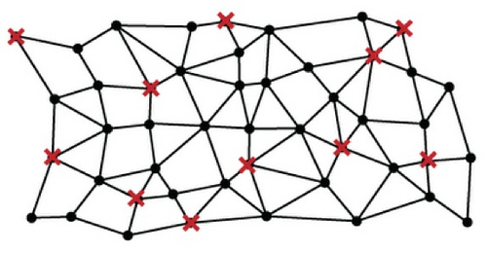

[4] The Author has explored about various aspects of the file system i.e. which implies security, transparency and data privacy of instigating along with The Internet of Things for a better data and healthy algorithm opacity which lacks the internal protocol security i.e. Encryption. This problem can be solved by opensource tool **OpenGPG.**

Thus, captivating all these characteristics into contemplation, A typical order of stages for our problem statement is:

1. Initialize the IPFS Daemon – ipfs init().
2. Setting the Topic for publish-subscribe.
3. Add Listeners.
4. Encrypt Channel data by Asymmetric Key Encryption.
5. Run scenarios using various cases (Related to accessibility).